**DAILY ONLINE ACTIVITIES SUMMARY**

|  |  |  |  |  |  |  |  |  |
| --- | --- | --- | --- | --- | --- | --- | --- | --- |
| **Date:** | **26/05/2020** | | | | | **Name:** | **Hanan Saleem Baji** | |
| **Sem & Sec** | **4th SEM 'A' Section** | | | | | **USN:** | **4AL18CS024** | |
| **Online Test Summary** | | | | | | | | |
| **Subject** | | **Design and Analysis of Algorithms** | | | | | | |
| **Max. Marks** | | **30** | | **Score** | | | **25** | |
| **Certification Course Summary** | | | | | | | | |
| **Course** | **1.Java Programming** | | | | | | | |
| **Certificate Provider** | | | **1. Great Learning Academy** | | **Duration** | | | **1. 1 hour** |
| **Coding Challenges** | | | | | | | | |
| **Problem Statement:** 1. Write a program in C to print all permutations of a given string using pointers.  2. Given an array A of size N where the array elements contain values from 1 to N with duplicates, the task is to find total number of subarrays which start and end with the same element. | | | | | | | | |
| **Status: completed** | | | | | | | | |
| **Uploaded the report in Github** | | | | | **Yes** | | | |
| **If yes Repository name** | | | | | 1. <https://github.com/saleemhananbaji/C-coding> 2. <https://github.com/saleemhananbaji/Java-coding> | | | |
| **Uploaded the report in slack** | | | | | **Yes** | | | |

ONLINE TEST DETAILS: Online test was conducted on the second module of **Design and Analysis of Algorithms**. Test contains 30 questions of 1 Mark each. I have scored 25 Marks.

Snapshot:

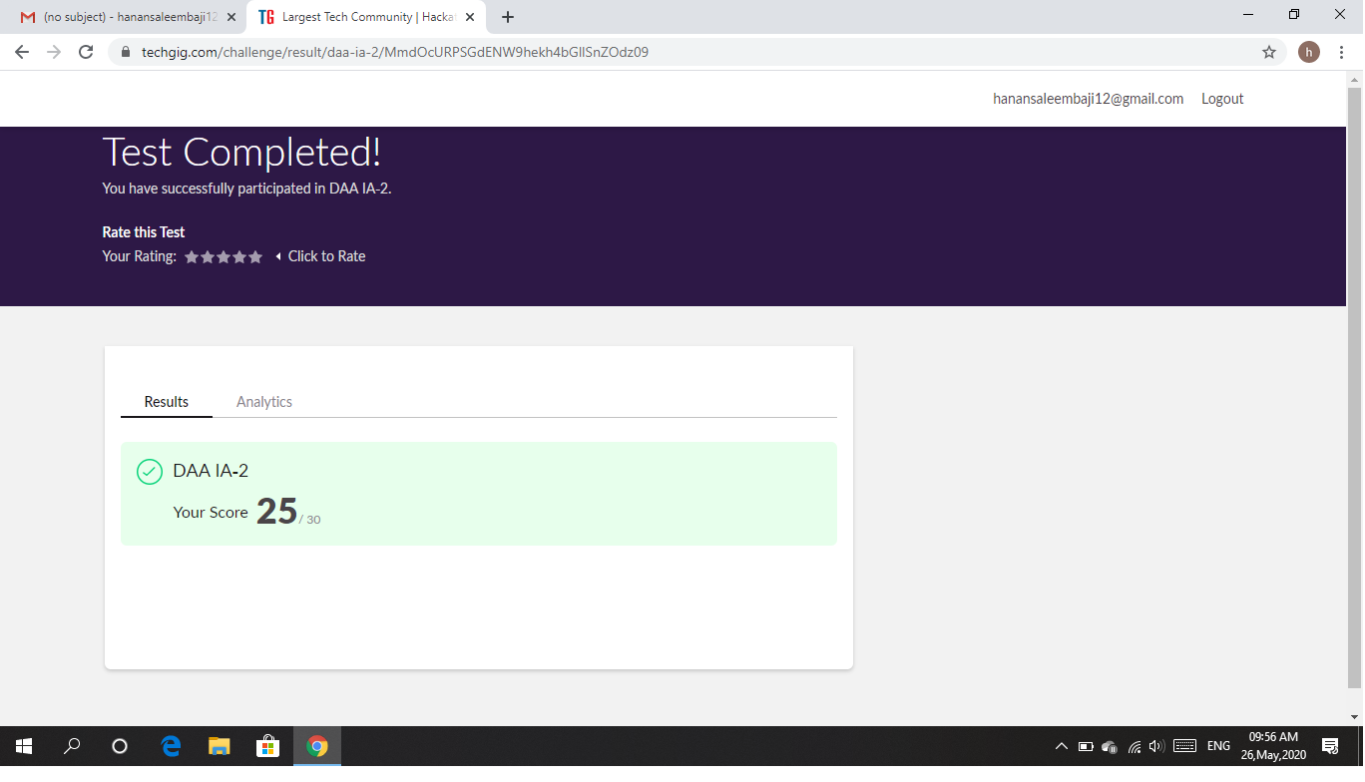

Certification Course Details: I have started with Java Programming certification course. Today, I have covered the topic such as what is Java, the installation of Java, Operators and control statement to be used in Java.

Snapshot:

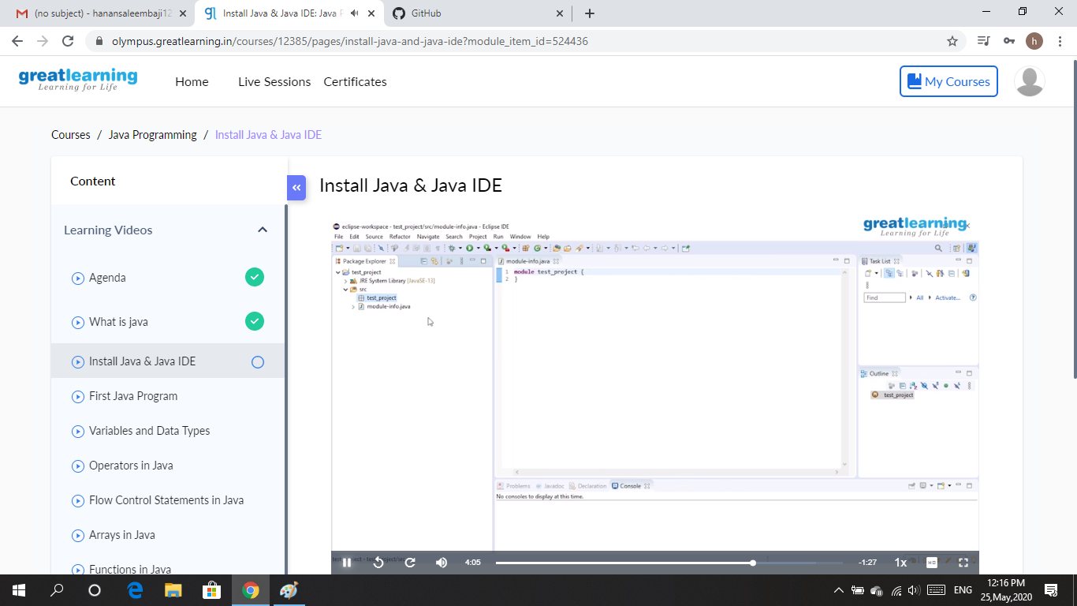

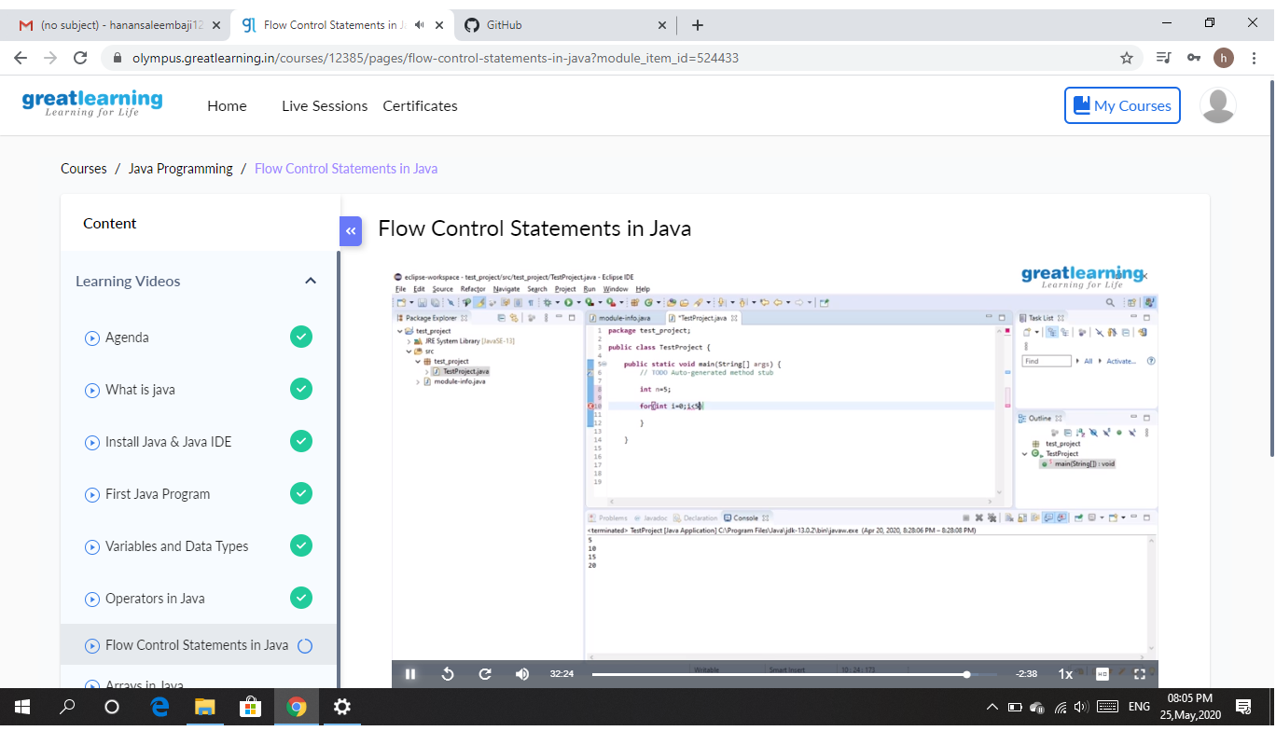

CODING CHALLENGES DETAILS: Problem statements

1. Write a program in C to print all permutations of a given string using pointers.

Solution : Uploaded it in github

Snapshot:

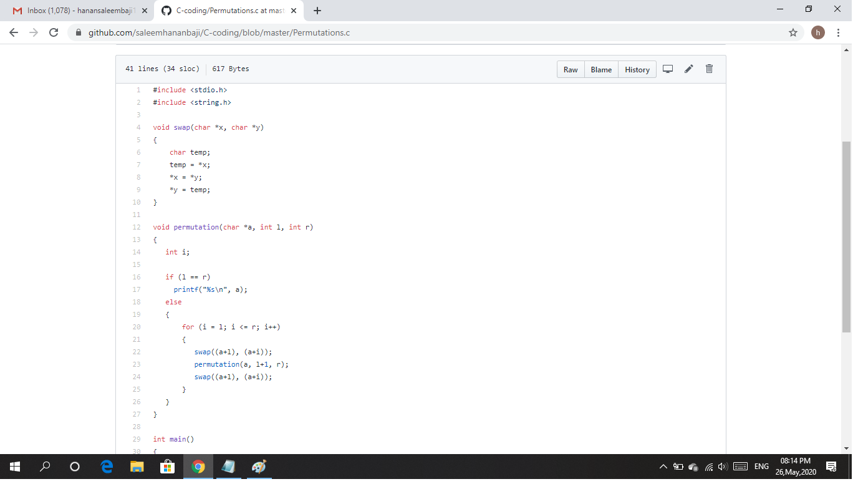

1. Given an array A of size N where the array elements contain values from 1 to N with duplicates, the task is to find total number of subarrays which start and end with the same element.

Solution : Uploaded it in github

Snapshot:

